**PWSkills Assignment 04**

**(Done By: Sunandan Sharma)**

**1.**

**Code:**

**(HTML)**

<!DOCTYPE html>

<html lang="en">

<head>

    <meta charset="UTF-8">

    <meta name="viewport" content="width=device-width, initial-scale=1.0">

    <title>Navigation Bar Example</title>

    <link rel="stylesheet" href="Style_1.css">

</head>

<body>

    <nav class="navbar">

        <ul class="nav-list">

            <li class="nav-item"><a href="#home"><u>Home</u></a></li>

            <li class="nav-item"><a href="#about us"><u>About Us</u></a></li>

            <li class="nav-item"><a href="#contact"><u>Contact</u></a></li>

            <li class="nav-item"><a href="#blog"><u>Blog</u></a></li>

            <li class="nav-item"><a href="#login"><u>Login</u></a></li>

        </ul>

    </nav>

</body>

</html>

**(CSS)**

body {

    margin: 0;

    font-family: Arial, sans-serif;

}

.navbar {

    background-color: #6594ee;

    overflow: hidden;

    padding: 10px 0;

}

.nav-list {

    list-style-type: none;

    margin: 0;

    padding: 0;

    display: flex;

    justify-content: flex-start;

}

.nav-item {

    margin: 0 15px;

}

.nav-item a {

    color: white;

    text-decoration: none;

    padding: 10px 20px;

    display: block;

}

.nav-item a:hover {

    color: #ff6347; /* Tomato color */

}

**Code GitHub link (HTML):** [**Assignment 04 - Q1 HTML Code Link**](https://github.com/Sunandanshrm/Web-Development/blob/master/Frontend/PwSkills/Assignment%2004/index_1.html)

**Code GitHub link (CSS):** **[Assignment 04 - Q1 CSS Code Link](https://github.com/Sunandanshrm/Web-Development/blob/master/Frontend/PwSkills/Assignment%2004/Style_1.css)**

**The Output:** [**Assignment 04 - Q1 Output Link**](https://drive.google.com/file/d/14nZxFeKThBmeTKrq2UTz-ge6d2BTnVFx/view?usp=drive_link)

**2.**

**Code:**

**(HTML)**

<!DOCTYPE html>

<html lang="en">

<head>

    <meta charset="UTF-8">

    <meta name="viewport" content="width=device-width, initial-scale=1.0">

    <title>Centered Div with Image and Paragraph</title>

    <link rel="stylesheet" href="Style_2.css">

</head>

<body>

    <div class="centered-container">

        <img src="Assets/image_2.jpeg" alt="Description of image" class="rounded-image">

        <p><b>Course Name:</b> Pw Skills full stack web development</p>

    </div>

</body>

</html>

**(CSS)**

body {

    margin: 0;

    display: flex;

    justify-content: center;

    align-items: center;

    height: 80vh;

    font-family: Arial, sans-serif;

    background-color: #f0f0f0;

}

.centered-container {

    text-align: left;

    max-width: 300px;

    padding: 10px;

    background-color: #fac42e;

    border-radius: 25px;

    box-shadow: 0 0 10px rgba(0, 0, 0, 0.1);

}

.rounded-image {

    width: 100%;

    height: auto;

    border-radius: 15px;

    margin-bottom: 20px;

}

**Code GitHub link (HTML):** [**Assignment 04 – Q2 HTML Code Link**](https://github.com/Sunandanshrm/Web-Development/blob/master/Frontend/PwSkills/Assignment%2004/index_2.html)

**Code GitHub link (CSS):** [**Assignment 04 – Q2 CSS Code Link**](https://github.com/Sunandanshrm/Web-Development/blob/master/Frontend/PwSkills/Assignment%2004/Style_2.css)

**The Output:**

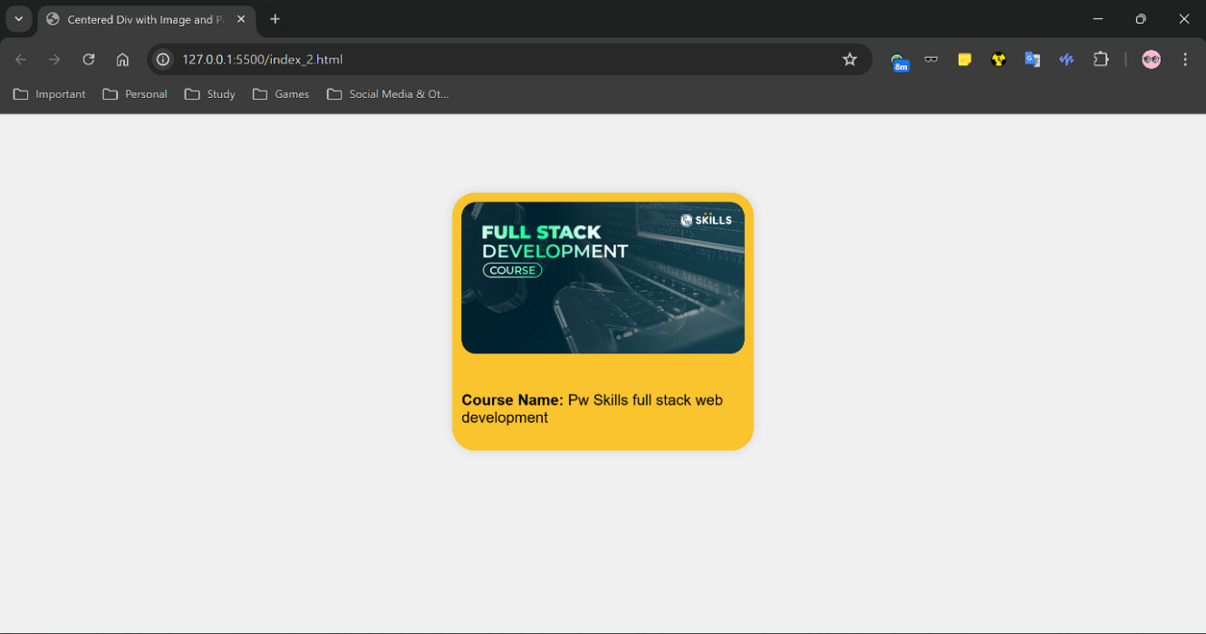

**3.**

**Code:**

**(HTML)**

<!DOCTYPE html>

<html lang="en">

<head>

    <meta charset="UTF-8">

    <meta name="viewport" content="width=device-width, initial-scale=1.0">

    <title>Navigation Bar Example</title>

    <link rel="stylesheet" href="Style_3.css">

</head>

<body>

    <nav class="navbar">

        <ul class="nav-list">

            <li class="nav-item border-style-1"><a href="#home"><u>Home</u></a></li>

            <li class="nav-item border-style-2"><a href="#about us"><u>About Us</u></a></li>

            <li class="nav-item border-style-3"><a href="#contact"><u>Contact</u></a></li>

            <li class="nav-item border-style-4"><a href="#blog"><u>Blog</u></a></li>

            <li class="nav-item border-style-5"><a href="#login"><u>Login</u></a></li>

        </ul>

    </nav>

</body>

</html>

**(CSS)**

body {

    margin: 0;

    font-family: Arial, sans-serif;

}

.navbar {

    background-color: #6594ee;

    overflow: hidden;

    padding: 10px 0;

}

.nav-list {

    list-style-type: none;

    margin: 0;

    padding: 0;

    display: flex;

    justify-content: flex-start;

}

.nav-item {

    margin: 0 15px;

}

.nav-item a {

    color: white;

    text-decoration: none;

    padding: 10px 20px;

    display: block;

}

.nav-item a:hover {

    color: #ff6347; /* Tomato color */

}

.border-style-1 {

    border: 2px solid red;

}

.border-style-2 {

    border: 2px dashed green;

}

.border-style-3 {

    border: 2px dotted blue;

}

.border-style-4 {

    border: 2px double yellow;

}

.border-style-5 {

    border: 2px groove purple;

}

**Code GitHub link (HTML):** [**Assignment 04 – Q3 HTML Code Link**](https://github.com/Sunandanshrm/Web-Development/blob/master/Frontend/PwSkills/Assignment%2004/index_3.html)

**Code GitHub link (CSS):** [**Assignment 04 – Q3 CSS Code Link**](https://github.com/Sunandanshrm/Web-Development/blob/master/Frontend/PwSkills/Assignment%2004/Style_3.css)

**The Output:** [**Assignment 04 – Q3 Output Link**](https://drive.google.com/file/d/12dY0d1K3GwWK8QhpQrPYH_FF8kmSjNKu/view?usp=drive_link)

**4.**

**Code:**

**(HTML)**

<!DOCTYPE html>

<html lang="en">

<head>

    <meta charset="UTF-8">

    <meta name="viewport" content="width=device-width, initial-scale=1.0">

    <title>Circular Image Example</title>

    <link rel="stylesheet" href="Style_4.css">

</head>

<body>

    <div class="container">

        <img src="Assets/image_4.png" alt="Description of image" class="circular-image">

    </div>

</body>

</html>

**(CSS)**

body {

    margin: 0;

    display: flex;

    justify-content: center;

    align-items: center;

    height: 100vh;

    font-family: Arial, sans-serif;

    background-color: #f0f0f0;

}

.container {

    text-align: center;

}

.circular-image {

    width: 400px; /* Set the desired width */

    height: 400px; /* Set the desired height */

    border-radius: 50%; /* Makes the image circular */

    object-fit: cover; /* Ensures the image covers the whole area */

    border: 5px solid #fff;

    box-shadow: 0 0 10px rgba(0, 0, 0, 0.3);

}

**Code GitHub link (HTML):** [**Assignment 04 – Q4 HTML Code Link**](https://github.com/Sunandanshrm/Web-Development/blob/master/Frontend/PwSkills/Assignment%2004/index_4.html)

**Code GitHub link (CSS):** [**Assignment 04 – Q4 CSS Code Link**](https://github.com/Sunandanshrm/Web-Development/blob/master/Frontend/PwSkills/Assignment%2004/Style_4.css)

**The Output:**

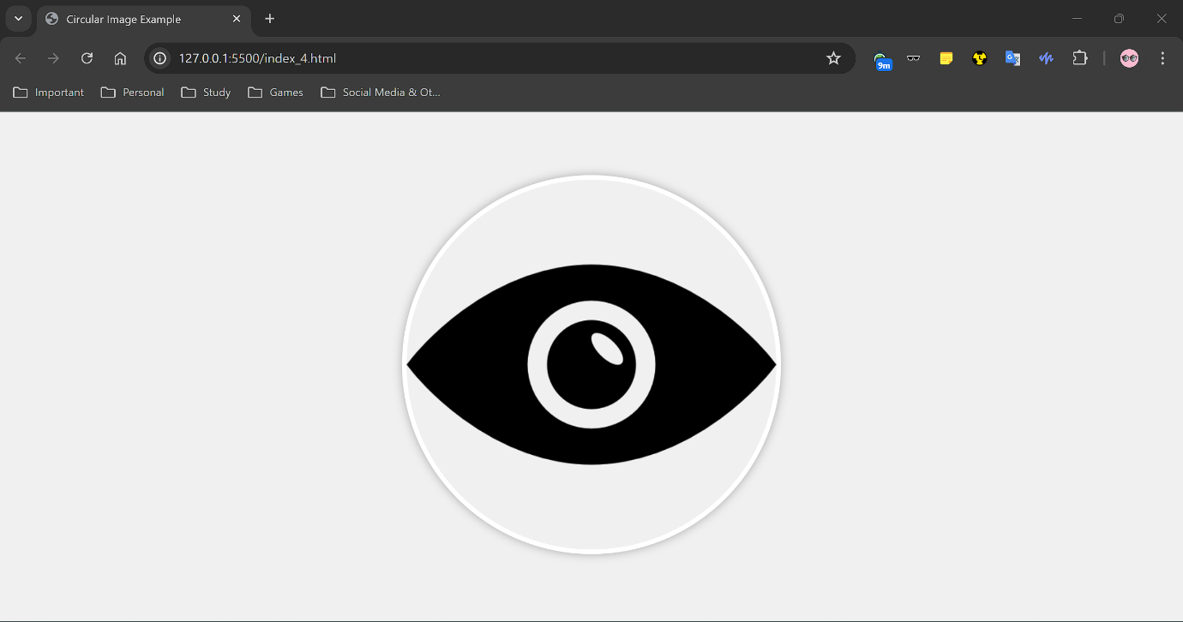

**5.**

**Code:**

**(HTML)**

<!DOCTYPE html>

<html lang="en">

<head>

    <meta charset="UTF-8">

    <meta name="viewport" content="width=device-width, initial-scale=1.0">

    <title>Blog about Google Fonts</title>

    <link href="https://fonts.googleapis.com/css2?family=Montserrat:wght@400;500&family=Oswald:wght@400;500&display=swap" rel="stylesheet">

    <link rel="stylesheet" href="Style_5.css">

</head>

<body>

    <div class="container">

        <h1>Google Fonts</h1>

        <img src="Assets/image_5_google_fonts.png" alt="Google Fonts" class="image">

        <p>Google Fonts is a library of over 1,000 free licensed font families and APIs for conveniently using the fonts via CSS and Android. The service was launched in 2010 and has since become a popular resource for web designers and developers, offering a vast selection of fonts that are easy to integrate into any web project.</p>

    </div>

</body>

</html>

**(CSS)**

body {

    margin: 0;

    padding: 0;

    font-family: 'Montserrat', sans-serif;

    background-color: #f0f0f0;

    display: flex;

    justify-content: center;

    align-items: center;

    height: 100vh;

}

.container {

    text-align: center;

    background-color: white;

    padding: 20px;

    border-radius: 10px;

    box-shadow: 0 0 10px rgba(0, 0, 0, 0.1);

    width: 80%;

    max-width: 600px;

}

h1 {

    font-family: 'Oswald', sans-serif;

    font-size: 2.5em;

    margin-bottom: 20px;

}

.image {

    width: 100%;

    height: auto;

    border-radius: 10px;

    margin-bottom: 20px;

}

p {

    font-family: 'Montserrat', sans-serif;

    font-size: 1em;

    line-height: 1.6;

}

**Code GitHub link (HTML):** [**Assignment 04 – Q5 HTML Code Link**](https://github.com/Sunandanshrm/Web-Development/blob/master/Frontend/PwSkills/Assignment%2004/index_5.html)

**Code GitHub link (CSS):** [**Assignment 04 – Q5 CSS Code Link**](https://github.com/Sunandanshrm/Web-Development/blob/master/Frontend/PwSkills/Assignment%2004/Style_5.css)

**The Output:**

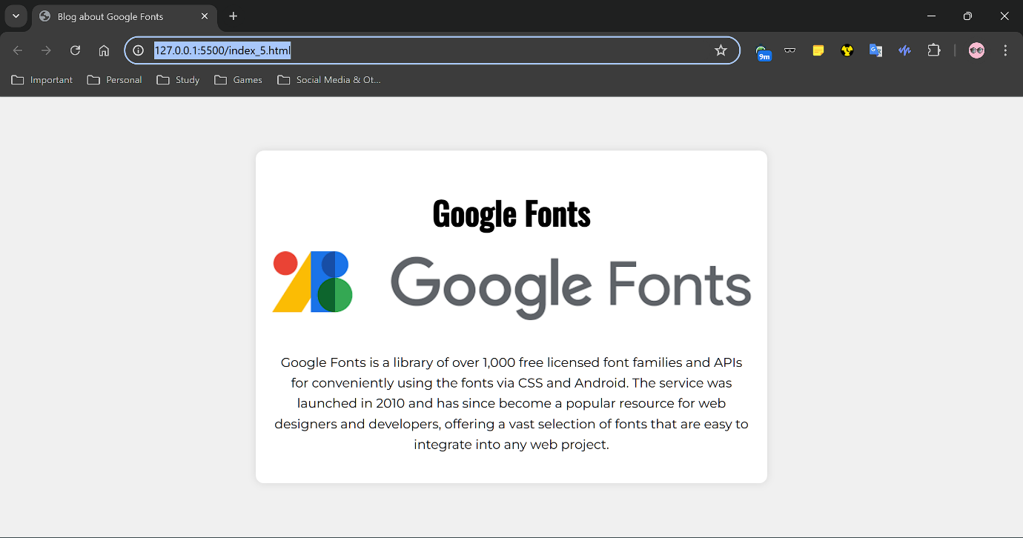

**6.**

**Code:**

**(HTML)**

<!DOCTYPE html>

<html lang="en">

<head>

    <meta charset="UTF-8">

    <meta name="viewport" content="width=device-width, initial-scale=1.0">

    <title>A Website Demo</title>

    <!-- Import Inter and Nunito Sans from Google Fonts -->

    <link href="https://fonts.googleapis.com/css2?family=Inter:wght@400;700&family=Nunito+Sans:wght@400;700&display=swap" rel="stylesheet">

    <link rel="stylesheet" href="Style_6.css">

</head>

<body>

    <div class="container">

        <h1>About Us</h1>

        <p>PW Skills' mission is to permeate through every student/professional's outlook towards jobs and change their attitude and perspective from "How Can I Do It?" to "Of Course I Can Do It". We aim to do this by providing exceptional up skilling courses at affordable rates, while being tech-forward so anyone, anywhere can access and improve their ability to be successful in life.</p>

        <img src="Assets/image_6_aboutUs.png" alt="image_asset" class="image">

    </div>

</body>

</html>

**(CSS)**

body {

    margin: 50px;

    padding: 0;

    font-family: 'Nunito Sans', sans-serif;

    background-color: white;

    display: flex;

    justify-content: center;

    align-items: center;

    height: 100vh;

}

.container {

    text-align: center;

    background-color: white;

    padding: 20px;

    border-radius: 20px;

    /*box-shadow: 0 0 10px rgba(0, 0, 0, 0.1);*/

    width: 90%;

    /*max-width: 600px;*/

}

h1 {

    margin: 30px;

    font-family: 'Inter', sans-serif; /* Use Inter for the heading */

    font-weight: 700; /* Bold */

    font-size: 36px;

    margin-bottom: 40px;

}

p {

    font-family: 'Nunito Sans', sans-serif; /* Use Nunito Sans for paragraphs */

    font-weight: 400; /* Regular */

    font-size: 16px;

    line-height: 24px;

    vertical-align: baseline;

    text-align: left;

    letter-spacing: normal;

    word-spacing: 0px;

}

.image {

    width: 100%;

    height: auto;

    border-radius: 10px;

    margin-bottom: 20px;

}

**Code GitHub link (HTML):** [**Assignment 04 – Q6 HTML Code Link**](https://github.com/Sunandanshrm/Web-Development/blob/master/Frontend/PwSkills/Assignment%2004/index_6.html)

**Code GitHub link (CSS):** [**Assignment 04 – Q6 CSS Code Link**](https://github.com/Sunandanshrm/Web-Development/blob/master/Frontend/PwSkills/Assignment%2004/Style_6.css)

**The Output:** [**Assignment 04 – Q6 Output Link**](https://drive.google.com/file/d/1EIGPscyLJHpN9cOzS6iKhZisKNbyhZy0/view?usp=drive_link)

**7.**

**Code:**

**(HTML)**

<!DOCTYPE html>

<html lang="en">

<head>

    <meta charset="UTF-8">

    <meta name="viewport" content="width=device-width, initial-scale=1.0">

    <title>Centered Div with Image and Paragraph</title>

    <link rel="stylesheet" href="Style_7.css">

</head>

<body>

    <div class="centered-container">

        <img src="Assets/image_2.jpeg" alt="Description of image" class="rounded-image">

        <p><b>Course Name:</b> Pw Skills full stack web development</p>

    </div>

</body>

</html>

**(CSS)**

body {

    margin: 0;

    display: flex;

    justify-content: center;

    align-items: center;

    height: 80vh;

    font-family: Arial, sans-serif;

    background-color: #f0f0f0;

}

.centered-container {

    text-align: left;

    max-width: 300px;

    padding: 10px;

    background-color: #fac42e;

    border-radius: 25px;

    box-shadow: 0 0 10px rgba(0, 0, 0, 0.1);

    opacity: 0.5;

}

.rounded-image {

    width: 100%;

    height: auto;

    border-radius: 15px;

    margin-bottom: 20px;

}

.centered-container:hover

{

opacity: 1;

}

**Code GitHub link (HTML):** [**Assignment 04 – Q7 HTML Code Link**](https://github.com/Sunandanshrm/Web-Development/blob/master/Frontend/PwSkills/Assignment%2004/index_7.html)

**Code GitHub link (CSS):** [**Assignment 04 – Q7 CSS Code Link**](https://github.com/Sunandanshrm/Web-Development/blob/master/Frontend/PwSkills/Assignment%2004/Style_7.css)

**The Output:** [**Assignment 04 – Q7 Output Link**](https://drive.google.com/file/d/1vVt0A0evr31WmPsWrj5iGaYXyTyYwHEw/view?usp=drive_link)

**8.**

**Code:**

**(HTML)**

<!DOCTYPE html>

<html lang="en">

<head>

    <meta charset="UTF-8">

    <meta name="viewport" content="width=device-width, initial-scale=1.0">

    <title>A Website Demo</title>

    <link rel="stylesheet" href="Style_8.css">

</head>

<body>

        <h1>Requirments</h1>

        <ol class="roman-numerals">

            <li>System with minimum i3 processor or better</li>

            <li>At least 4 GB of RAM</li>

            <li>Working internet connection</li>

            <li>Dedication to learn</li>

        </ol>

    </div>

</body>

</html>

**(CSS)**

body {

    margin: 0;

    padding: 0;

    font-family: Arial, sans-serif;

    background-color: #f0f0f0;

    display: flex;

    flex-direction: column;

    justify-content: center;

    align-items: left;

    height: 50vh;

}

h1 {

    font-size: 2em;

    margin-bottom: 20px;

    text-align: left;

    margin: 10px;

}

.roman-numerals {

    list-style-type: lower-roman;

    padding-left: 20px;

    text-align: left;

    margin: 20px; /* To remove the default margin of the ordered list */

}

.roman-numerals li {

    font-size: 1em;

    margin-bottom: 10px;

}

**Code GitHub link (HTML):** [**Assignment 04 – Q8 HTML Code Link**](https://github.com/Sunandanshrm/Web-Development/blob/master/Frontend/PwSkills/Assignment%2004/index_8.html)

**Code GitHub link (CSS):** [**Assignment 04 – Q8 CSS Code Link**](https://github.com/Sunandanshrm/Web-Development/blob/master/Frontend/PwSkills/Assignment%2004/Style_8.css)

**The Output:**

